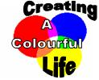
Ancient Art Practical Key Stage 2 Lesson Planning

Scheme of work unit: Characteristics of materials
Rocks and soils

National Curriculum link:

Knowledge, skills and understanding Sc3 Materials and their properties

Grouping and classifying materials.

Pupils should be taught:

to describe and group rocks and soils on the basis of their characteristics, including appearance, texture and permeability (in this case the properties required to be able to use the rocks to make pigments could be discussed and contrasted with rocks which couldn’t be used for this purpose)

to recognise differences between solids, liquids and gases, in terms of ease of flow and maintenance of shape and volume.

Changing materials
Pupils should be taught:
- to describe changes that occur when materials are mixed
- that non-reversible changes result in the formation of new materials that may be useful (in this case the paint has new properties – although pigments are insoluble you cannot separate them from the binder again ie irreversible change)

Learning outcomes:

Rocks and soils:
State that underneath all surfaces is rock which we may not be able to see, rocks get broken down into pebbles and soils which we can often see, and that there are different sorts of rock with different characteristics. Pebbles and soils from different rocks consequently have different characteristics.

Particle model:
Describe how new materials can be formed and how their properties can be useful. Compare natural paint and modern paint in terms of colours, formation and uses. (link science knowledge and technology to the development of paint and how we can develop paint with particular properties to suit our use)

Information:

- Cave paintings have been found throughout the world, from dark limestone caves in the South of France to rock shelters in Zimbabwe.
- Cavemen had limited knowledge about pigments, and few tools with which to make them. So they used the minerals around them to obtain colours.
- They would grind the minerals to a fine powder, and then use saliva, ear wax or animal fat to make the paint stick to the surface.
- They used chewed twigs as brushes.
- By the time of the Ancient Egyptian era there were more colours available. These were made by heating natural materials.
- The Egyptians traded new brightly coloured minerals, such as Saffron. The Egyptians also developed better tools to grind them with.
- Egyptians found ways of extracting sap from plants, as well as using milk from cows to bind their pigments together to form paint.
- By Medieval times, people travelled and traded even more widely across Europe. A large variety of colours were now becoming available.

Suggested Lesson Plan:

Starter
Discuss with pupils how they think cavemen painted pictures on their cave walls. Invite them to give ideas about what they would use for paints, brushes etc. Compare and contrast the colours obtained naturally with the man-made pigments available today. Explore how a caveman might “lighten” the colours they were using.

→ Link to making new substances or to use of rocks and soils to share learning objectives depending on the unit studied

Main activity:
Pupils to compare paints made from natural materials and modern day paints with the samples provided.

Then pupils make their own paint and use it to paint a picture.
Worksheet with questions available.

Plenary:
Rocks and soils:
Discuss properties of rocks required to be used to paint. Cavemen would have had to use very hard rocks to grind others into fine powders (different hardness). Porous rocks tend to be less hard than non porous rocks. Different colours could be obtained by using different rocks but the range would have been limited. They would have used other natural pigments (plants for example) to make other colours.

Particle model:
Discuss differences in natural paint and modern paint in terms of colours, formation and uses.

Resources Required:

For detailed information about sourcing the materials please see our resources sheet. http://www.creatingacolourfullife.co.uk/download/resourcelist.pdf

For this experiment it is only necessary to have an example of a natural pigment and one of a man-made pigment.

- Natural pigment (Ancient): Iron Oxides (yellow, red)
Malachite
Chalk Rock
Ultramarine Blue
Chalk Sticks
- Man-Made pigment (Modern): Powder Paints
- PVA Glue
- Eggs (Optional)
- Pestle & Mortar (if grinding is required)
- Plastic Cups
- Spoons
- Paint Brushes
- Something to paint

Health and safety:

If using eggs as a binder, be sure there are no allergies towards them.
Care must be taken when grinding the ancient materials.

Further Work:

Pupils can make their own “cave chalk stick” using egg shells. Information about this is available on our website – www.creatingacolourfullife.co.uk under the experiments section. Relates to the concept that materials can be mixed together to form a new, usable item.

The ancient and modern paints that the children have made can be used to make a display, outlining what they have learned.

Answers worksheet:

- Minerals and rocks
- Spit, animal fat and/or ear wax.
- Browns, dark oranges, dark reds.
- Modern day paints are a lot brighter. Much wider selection of colours.
- Paint pigment: Dry, fine powder, not sticky, solid.
Binder: Very sticky, viscous, liquid.
- Sap from plants and milk from cows.
Ancient Art Practical

Introduction

Cave paintings have been found throughout the world. Cavemen had very few tools available to them, and they had to use the minerals and rocks around them to obtain colours. They would dig these minerals and rocks from the ground and then grind them into a fine powder.
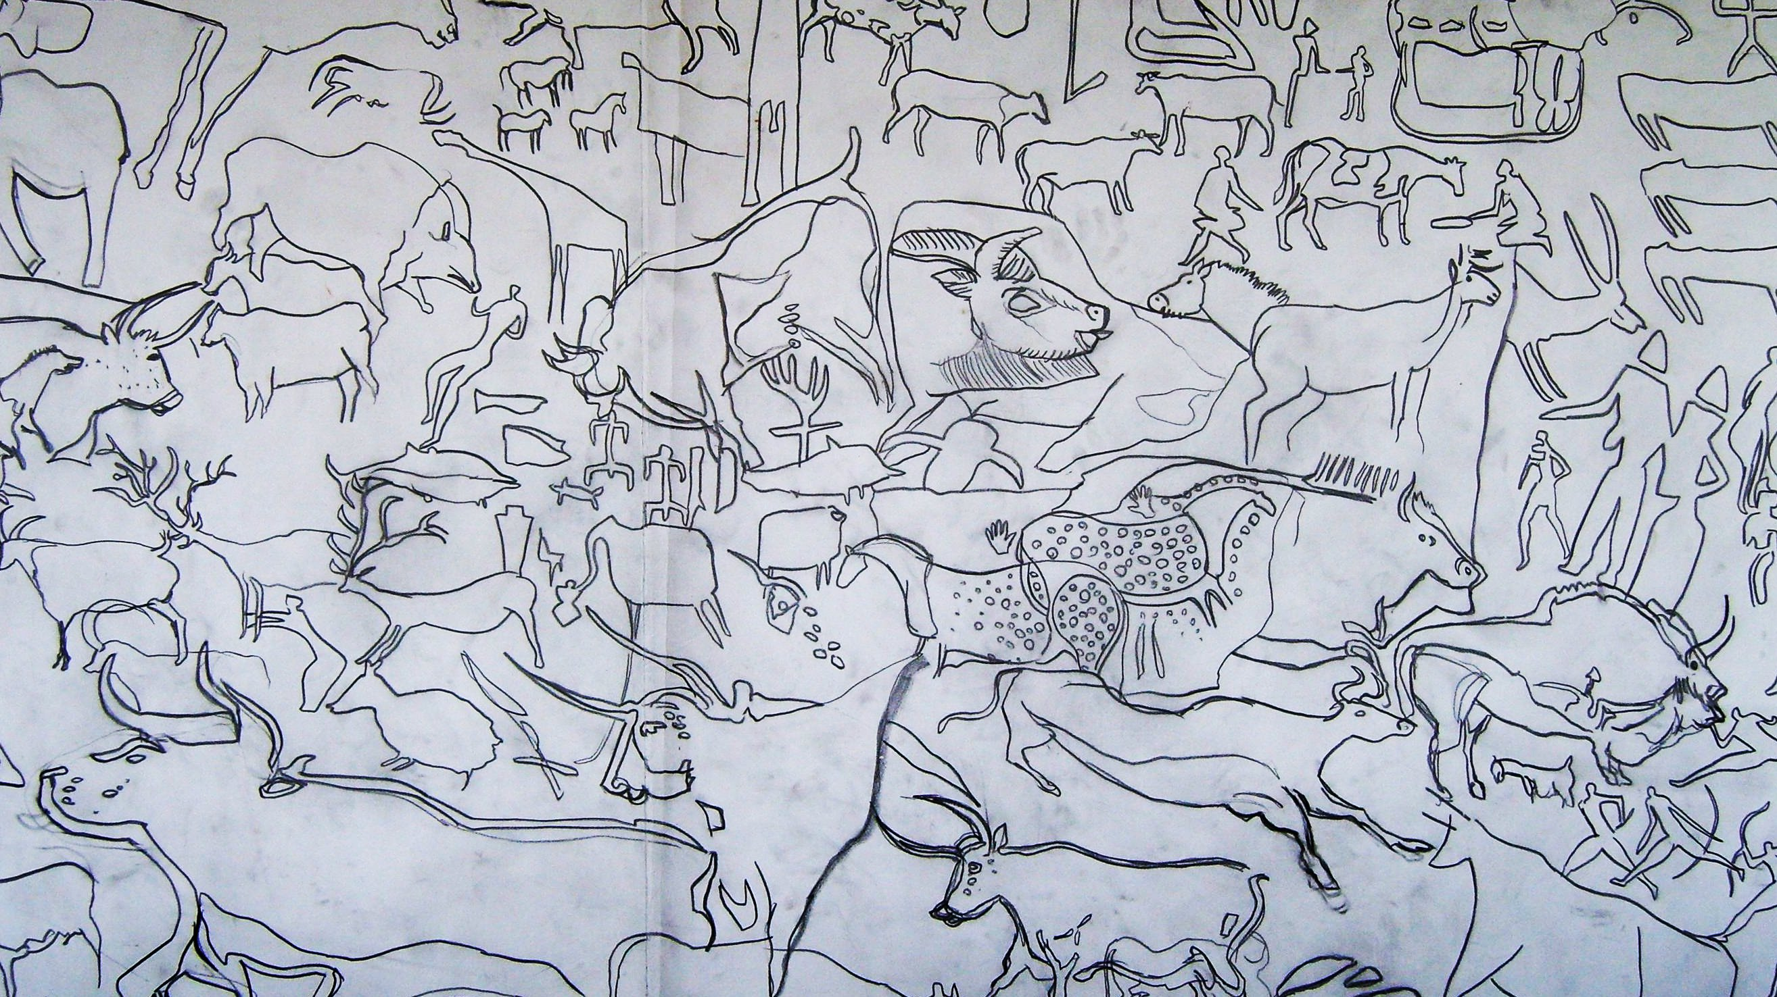

Modern cave art drawing.

The cavemen would use their spit, animal fat or ear wax to make their paints stick to the cave walls.

Cavemen would also use their fingers and the end of chewed twigs to paint their pictures.

By the time of the Ancient Egyptian era there were more colours available. They found new brightly coloured minerals, and better tools to grind them with.

Egyptians found ways of extracting sap from plants, as well as using milk from cows to bind their pigments together to form paint.

By Medieval times people travelled and traded even more widely across Europe. A large variety of colours were now becoming available.

In this practical you will pretend that you are a caveman, and use natural materials in order to paint pictures, just like the cavemen did. You will also paint pictures using modern day paints and compare the colours.

Practical:

- Look at both the natural pigments and the man made pigments. What are the differences between them? Which is your favourite pigment?
- Add a teaspoon of your favourite pigment to a plastic cup. If you are using a natural material, make sure it has been ground to a fine powder first.
- Add a few drops of water and mix with a brush until you have a smooth paste.
- Separate the egg yolk from the egg white and dispose of the egg white. Add the egg yolk to your plastic cup. (If you are using PVA glue, add 2 teaspoons of it to the plastic cup instead).
- Mix the egg yolk with your pigment paste using a paint brush.
- You are ready to paint.

Questions:

- What did the cavemen use to make their paints?

………………………………………………………………………………………………….

…………………………………………………………………………….……………………

- How did cavemen make their paints stick to the cave walls?

…………………………………………………………………………….……………………

- Which colours did the cavemen have to paint with?

………………………………………………………………………….………………………

- What are the differences between the ancient cavemen paints and the modern day paints?

……………………………………………………………………….…………………………

………………………………………………………………………….………………………

- What are the properties required to make a good binder?

…………………………………………………………………….……………………………

………………………………………………………………………….………………………

- What did the Egyptians use to bind their pigments together to form paint?

……………………………………………………………………….…………………………

…………………………………………………………………….……………………………

